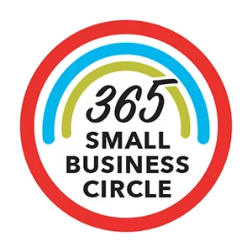
Name of Business: | Click or tap here to enter text.
Contact Name: | Click or tap here to enter text.
Phone Number: | Click or tap here to enter text.
Mailing Address: | Click or tap here to enter text.
Email Address: | Click or tap here to enter text.

☐ | I am pledging $365 and would like to be included in the Small Business Circle.
☐ | Other: I am pledging $ Click or tap here to enter text. and would like to be included in the Small Business Circle and receive additional recognition based on donor level.*  - Bronze ($1,200 - $2,499)  - Silver ($2,500 - $4,999)  - Gold ($5,000 - $24,999)  - Benefactor ($25,000 - $49,999)  *the total donation includes the $365 membership pledge.

Payment Type:
☐ | My payment is enclosed in full.
☐ | I processed my gift online at https://fmwbunitedway.com/
☐ | Please invoice me for my entire payment

MEMBER BENEFITS | I WANT TO KNOW MORE ABOUT:
- 365 Small Business Circle window decal | ☐ | Hosting a 365 Network Event
- Invitation to our events | ☐ | Days of Caring Team Building
- Engagement on social media | ☐ | Volunteer Opportunities
- Company Logo on our Website and Link to your Website | ☐ | Gifts in Kind
- Recognition in our Annual Report | ☐ | Red Menu Campaign

Signature: | Date: Click or tap to enter a date.

